Written Concept for Habit Tracker Application

Introduction:

The Habit Tracking Application is designed to help users build and maintain positive habits by providing tools for habit creation, tracking, and analysis. This application utilizes Python programming language along with MySQL database for efficient data storage and management.

Technical Foundations:

Python Libraries: The application utilizes various Python libraries including pandas, datetime, tabulate, time, threading, mysql.connector, and questionary for data manipulation, time management, database interaction, and user input handling.

Database Integration: MySQL database is used to store habit-related data such as habit name, duration, start date, minutes saved, check status, streak, and habit type.

User Interface: User interactions are facilitated through the questionary library, providing a simple and interactive command-line interface for creating, removing, and analyzing habits.

Habit Class:

The Habit class encapsulates methods for habit creation, removal, tracking, and analysis.

Habit creation involves gathering user input such as habit name, start date, duration, and habit type (daily or weekly) through interactive prompts.

Habit removal allows users to delete existing habits from the database based on habit name input.

Habit tracking includes functionalities for checking off habits, updating streaks, and managing habit timers.

User Interaction:

Creating Habit: Users can create new habits by providing details such as habit name, start date, duration, and type (daily or weekly) using interactive prompts.

Removing Habit: Users have the option to remove existing habits from the database by inputting the habit name.

Analyzing Habit: Users can analyze their habits by viewing all habits, checking off habits, identifying the longest streak, the latest streak, habits struggled the most, habits struggled the least, and listing all daily or weekly habits.

Shutdown: Users can gracefully exit the application using the shutdown option.

Diagram:

[Insert UML diagram illustrating the interaction of components and the process flow of the application.]

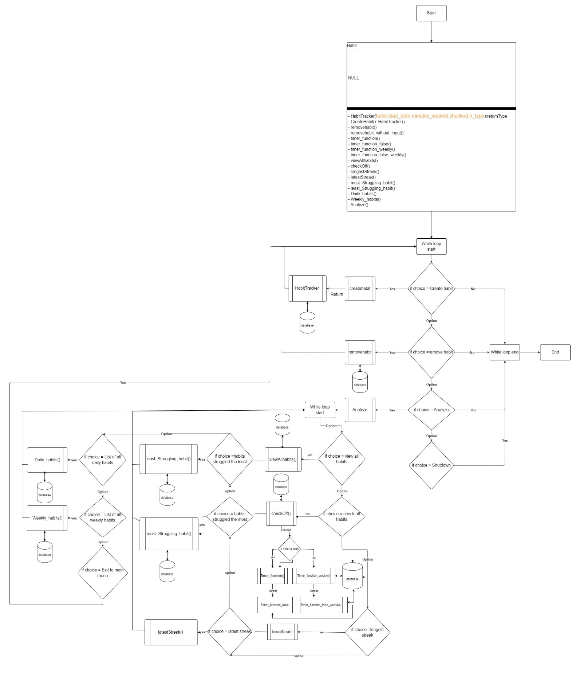

Justification:

The chosen design ensures a streamlined user experience, emphasizing simplicity and usability. By focusing on essential features and intuitive design principles, we aim to maximize user engagement and retention.

Conclusion:

The Habit Tracking Application provides a comprehensive solution for users to develop and maintain positive habits. Through its intuitive interface and robust functionalities, users can easily create, track, and analyze their habits to achieve personal growth and productivity.